**Final Deliverables**

|  |  |
| --- | --- |
| Team ID | PNT2022TMID43432 |
| Project Name | Personal Assistance for Seniors Who Are SelfReliant |

# Web Application

## Get Data From User:

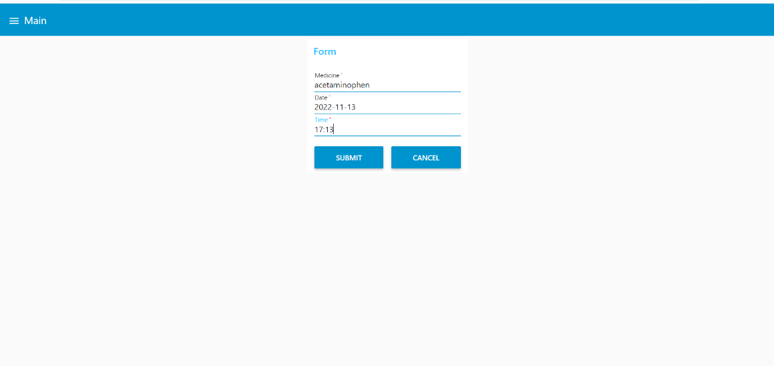

1. Stored in Cloudant

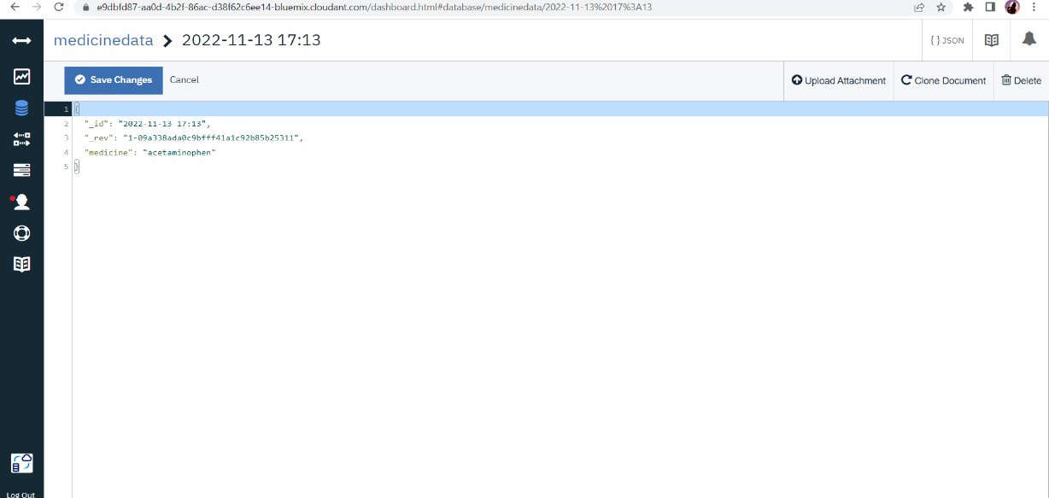

## Display in Node-red

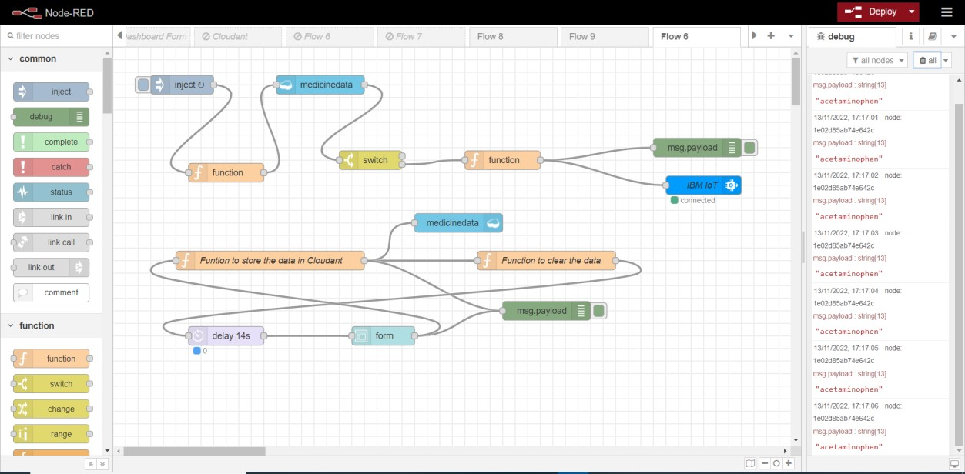

1. Streaming in Watson IoT Platform

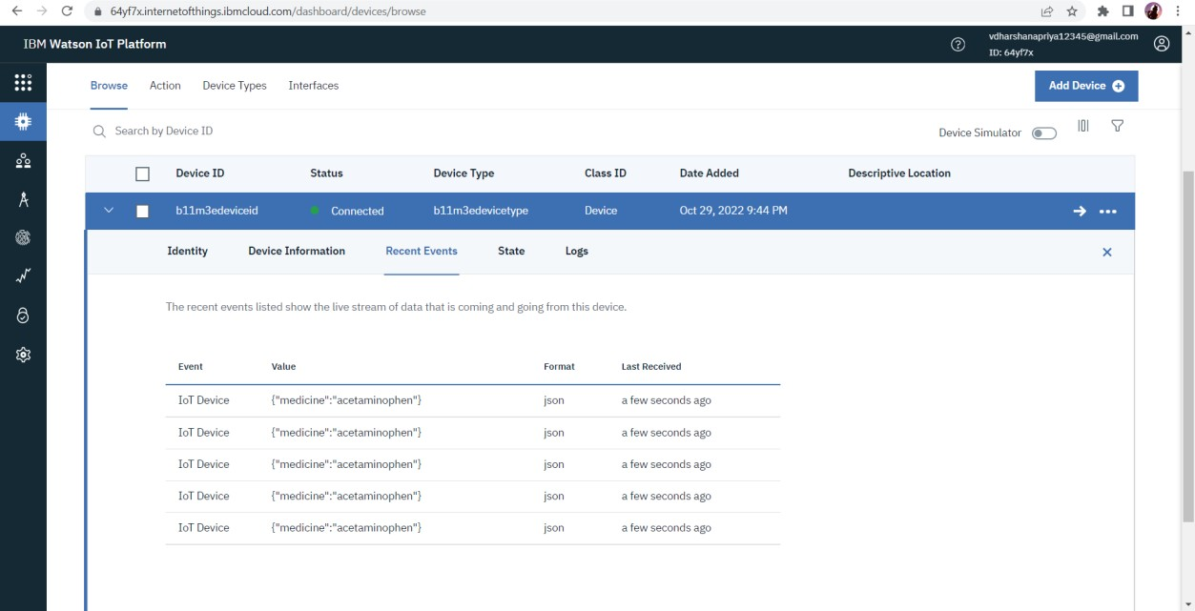

# Mobile Application

1. Splash Screen

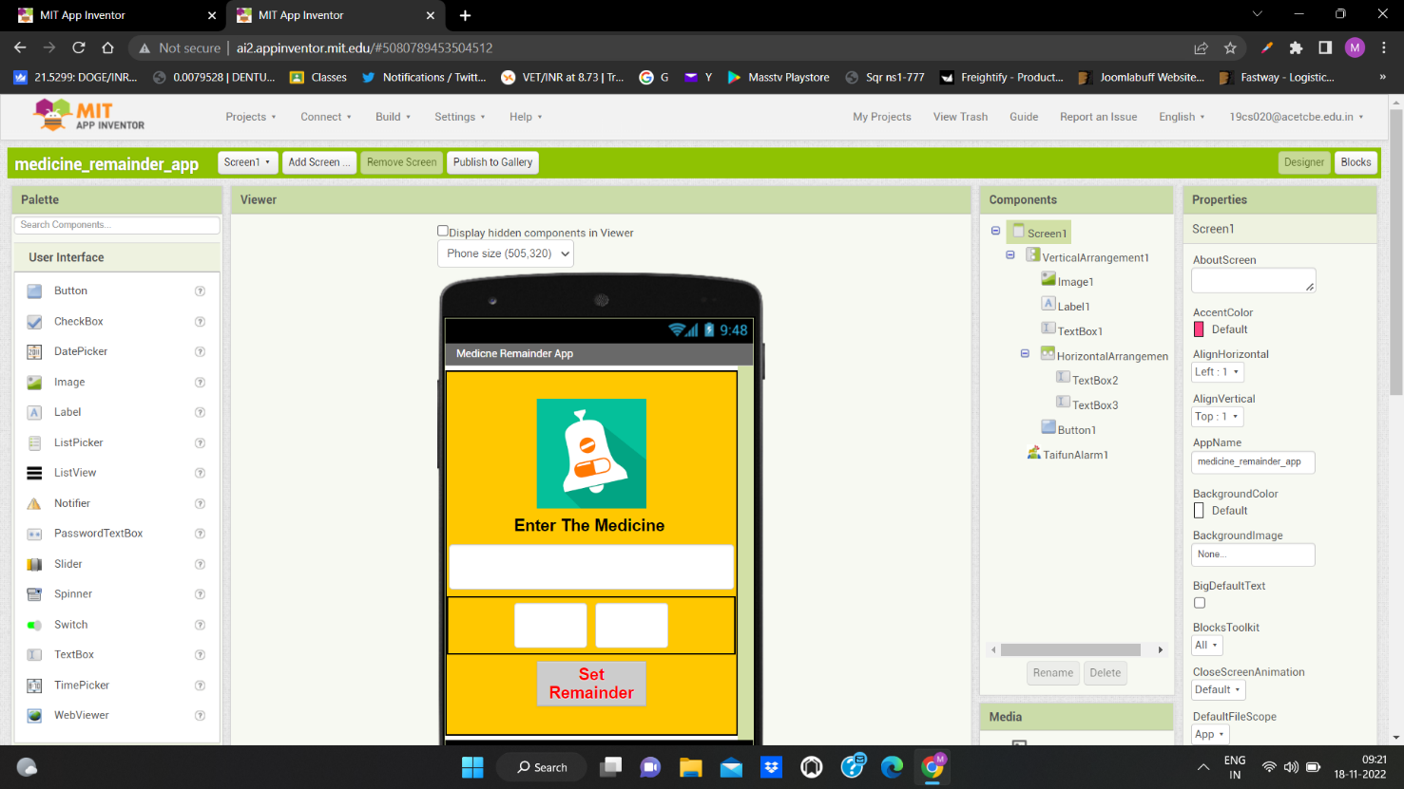

2 . Block For Splash Screen :

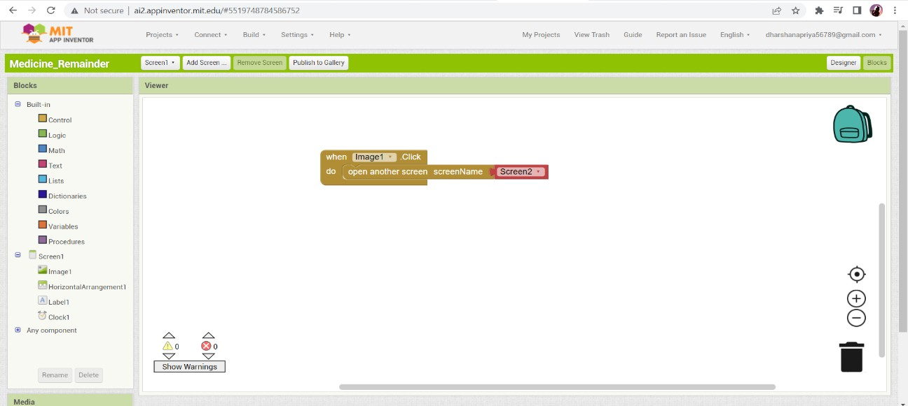

2.Blocks For Remainder

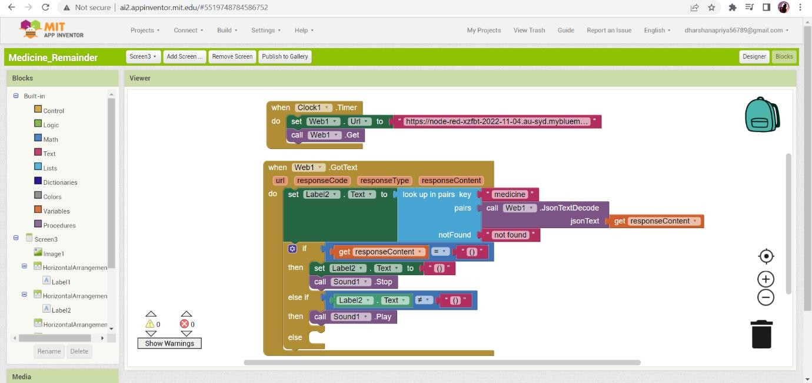

3.Store in Cloudant DB

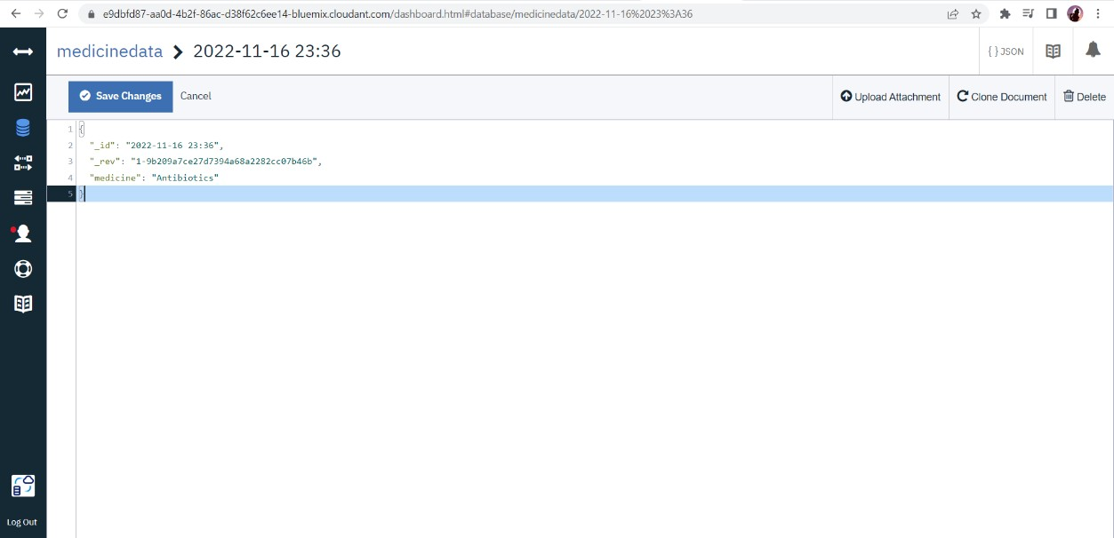

1. Display remainder with audio :

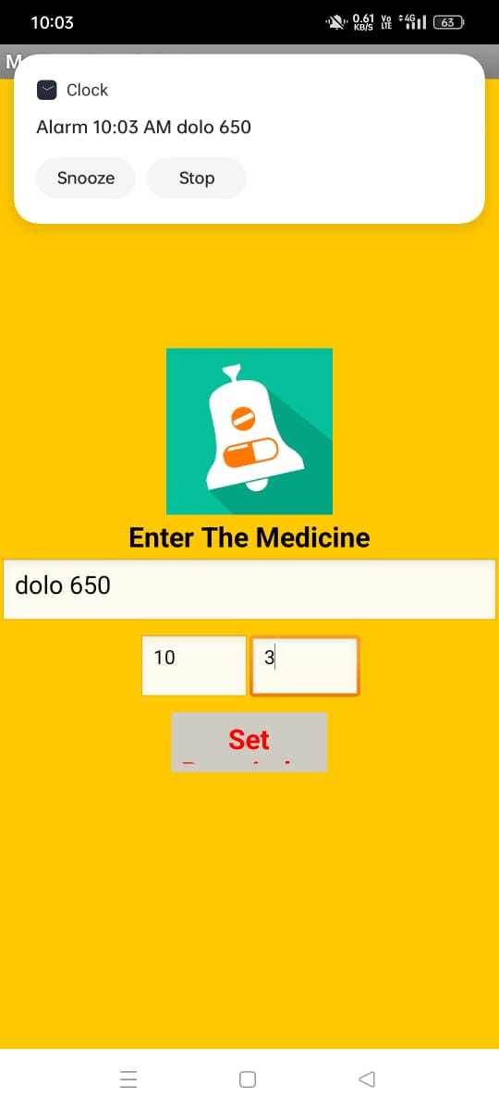

Demo Link :

<https://drive.google.com/file/d/1FujwHIz9ITEA03FAhx5raPlO3UiQQtW/view?usp=share_link>